Lab Practice 2 – Database Systems

Roll No: 2k19/IT/42 Name: HASNAIN ALI SHORO

Practice Question 1

Show the structure of the DEPARTMENTS table AND Select all data from the table.

See output below
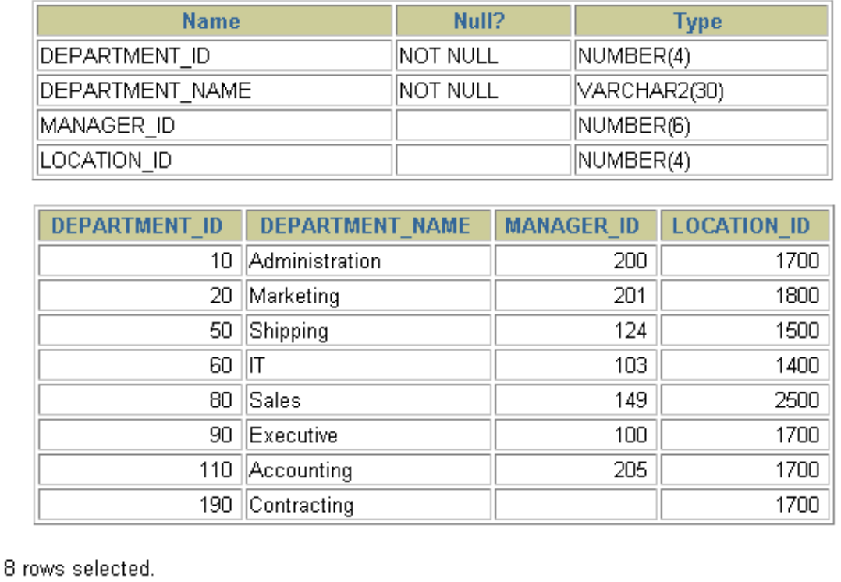
Practice Question 2

- Show the structure of the EMPLOYEES table.

- Create a query to display the last name, job code, hire date, and employee number for each employee, with employee number appearing first. Provide an alias STARTDATE for the HIRE_DATE column.

See output below
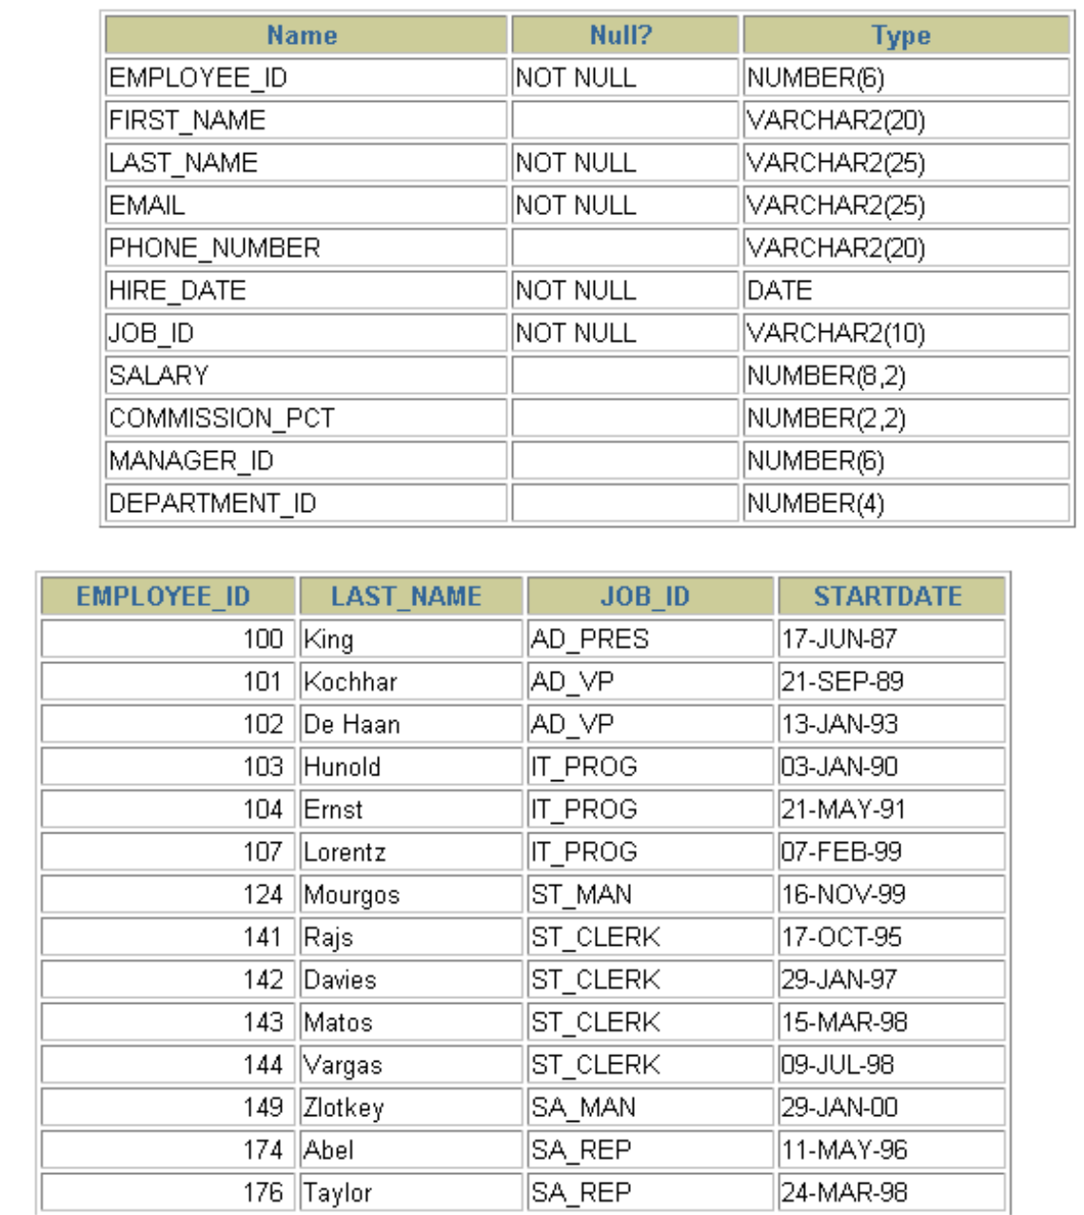
Practice Question 3

Create a query to display unique job codes from the EMPLOYEES table.

See output below
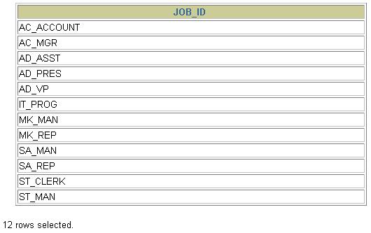

Practice Question 4

Show all employees data and show data under Column heading as Emp #, Employee, Job, and Hire Date, respectively.

See output below
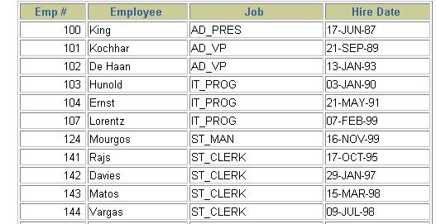
Practice Question 5

Display the last name concatenated with the job ID, separated by a comma and space, and name the column Employee and Title.

See output below
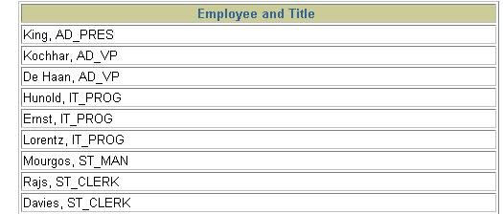

Practice Question 6

Create a query to display all the data from the EMPLOYEES table. Separate each column by a comma. Name the column THE_OUTPUT.

See output below
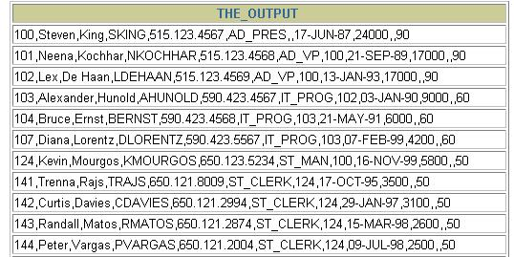
Answers

Practice Question 1

DESCRIBE departments
SELECT *
FROM departments;

Practice Question 2

DESCRIBE employees
SELECT employee_id, last_name, job_id, hire_date
FROM employees;

Practice Question 3

SELECT DISTINCT job_id
FROM employees;

Practice Question 4

SELECT employee_id "Emp #", last_name "Employee",
job_id "Job", hire_date "Hire Date"
FROM employees;

Practice Question 5

SELECT last_name||', '||job_id "Employee and Title"
FROM employees;

